Afr-Nigeria-Igbo-Door-Large

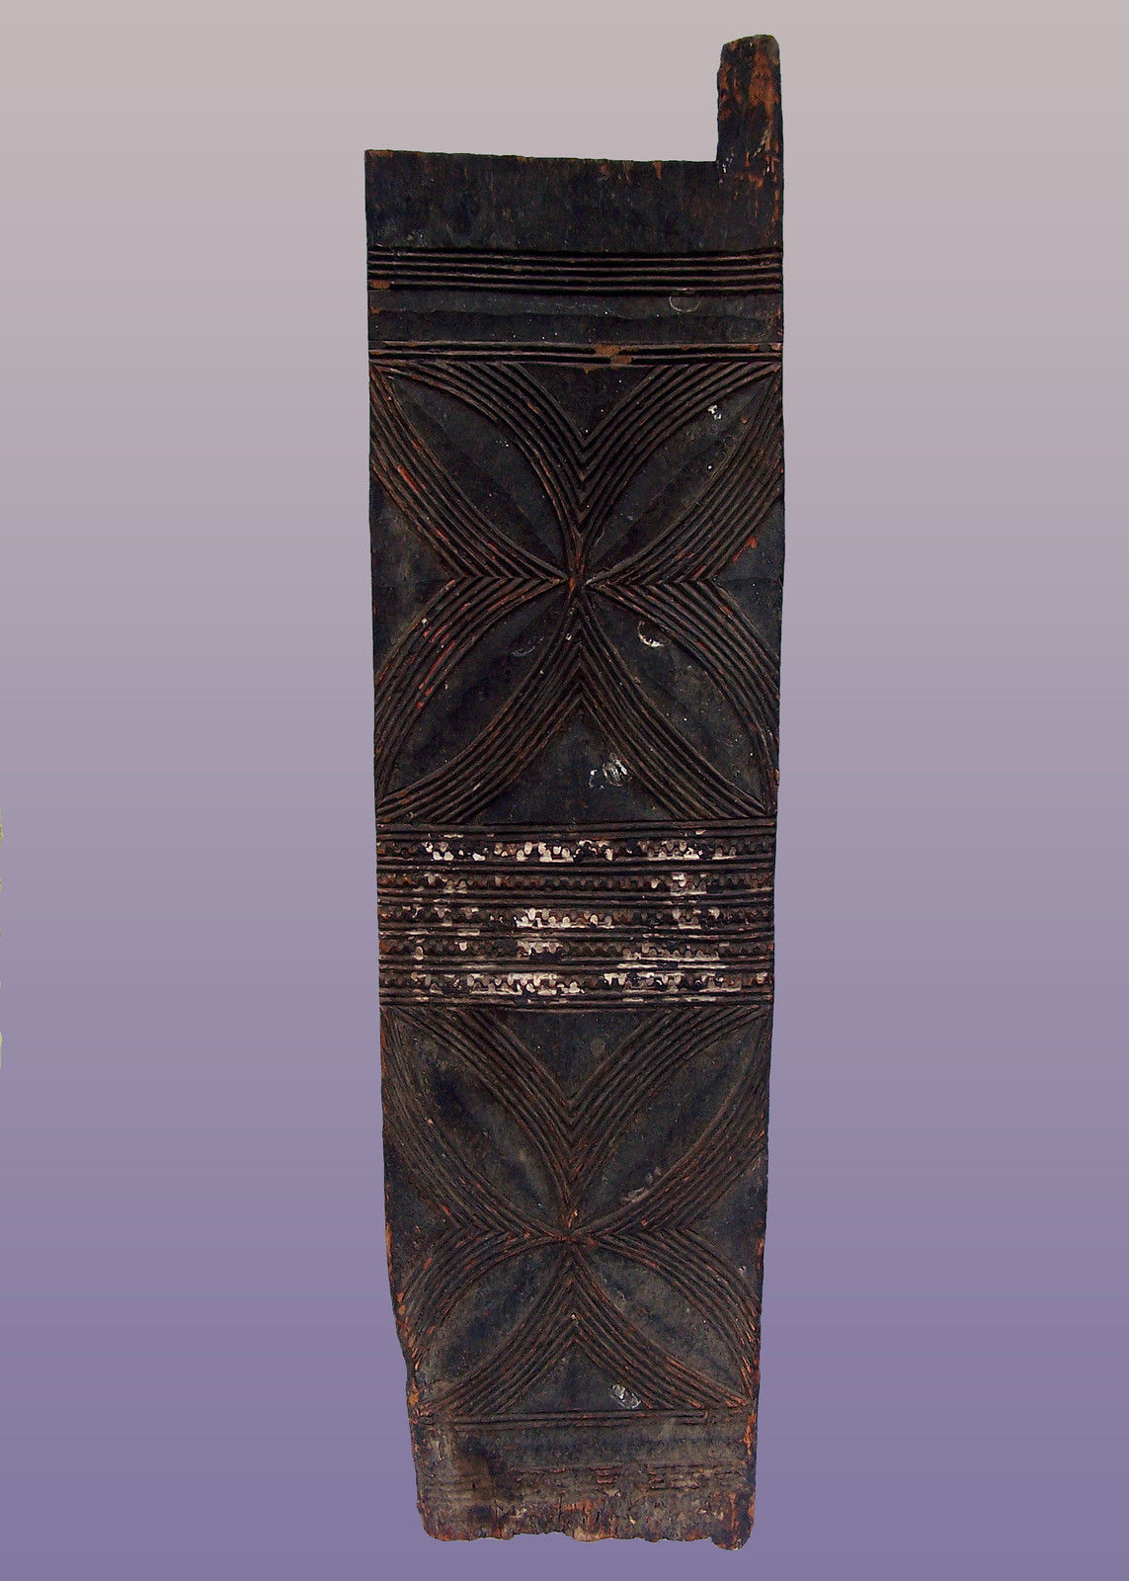

**Large Igbo Door from Nigeria 65"h x 17"w x 1"d**

Price:

US $1,495.00